yum
======
- configure local yum repository in Redhat Linux? repository file name should be local-data.
Mount the installation DVD or ISO:
mount /dev/cdrom /mnt
Create repository file:
vi /etc/yum.repos.d/local-data.repo
Add the following configuration:
[local-data]
name=Local Repository
baseurl=file:///mnt/BaseOS
enabled=1
gpgcheck=0
Clear cache and check repo:
yum clean all
yum repolist

- Repo ?Also configure client repository using ftp ?
Create repository file on client:
vi /etc/yum.repos.d/ftp.repo
Add configuration:
[ftp-repo]
name=FTP Repository
baseurl=ftp://192.168.1.10/pub/repo
enabled=1
gpgcheck=0
Refresh yum:
yum clean all
yum repolist

- Difference between rpm and yum?

RPM | YUM
Low-level package manager | High-level package manager
Installs .rpm packages manually | Installs packages from repositories
Does not resolve dependencies automatically | Automatically resolves dependencies
Command: rpm | Command: yum

- write command to install package?
yum install httpd
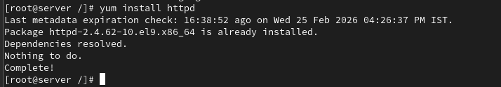

- How to get the package information using yum?
Yum info httpd
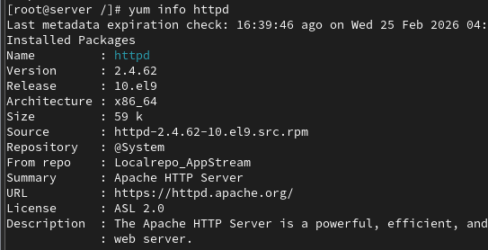

- How to find files belongs to which rpm package?
rpm -qf /usr/sbin/httpd

- How to check the updates for yum repository?

yum check-update

- How to know the particular files belongs to which package?
yum provides /etc/httpd/conf/httpd.conf

- How to remove the package using yum?
yum remove httpd

- How to list the enabled repositories?
yum repolist

- How to get the list of dependencies for specific package?
yum deplist httpd

- How to display a list of recently installed software?
yum history list

- How to display the list of installed software package’s files?
rpm -ql httpd

- How to install specific software package using rpm command on Redhat Linux?
rpm -ivh httpd-2.4.37.rpm

- How to remove the software package from on Redhat Linux?
rpm -e httpd

- what is the repository file location?
/etc/yum.repos.d/

- write yum configuration file?
/etc/yum.conf

LVM
====
- Is it possible to increase the logical volume online?
Yes. LVM allows online extension of logical volumes.
Example:
lvextend -L +2G /dev/vgname/lvname
xfs_growfs /mountpoint

- how to remove LVM completely from the host?
Steps:
- Unmount filesystem
umount /mountpoint
- Remove logical volume
lvremove /dev/vgname/lvname
- Remove volume group
vgremove vgname
- Remove physical volume
pvremove /dev/sdb

- how to reduce lvm file system?
umount /mountpoint
e2fsck -f /dev/vg/lv
resize2fs /dev/vg/lv 3G
lvreduce -L 3G /dev/vg/lv
mount /mountpoint

- In MBR how many numbers of partition can create?
Maximum 4 primary partitions
or
3 primary + 1 extended

- In GPT how many numbers of partition can create?
Up to 128 partitions

- what are the commands to create partition?
fdisk /dev/sdb
view partitions
lsblk

- what is the command to create volumegroup?
vgcreate vgname /dev/sdb
Example:
vgcreate vgdata /dev/sdb

- what is the command to create logical volume?
lvcreate -L 2G -n lvdata vgdata

- how to create ext4 and xfs file system?

EXT4:
mkfs.ext4 /dev/vgdata/lvdata
XFS:
mkfs.xfs /dev/vgdata/lvdata

- how to scan physical volume?
Pvscan
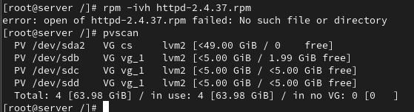

- what are the field in /etc/fstab?

Example:
/dev/sdb1 /data ext4 defaults 0 0
Fields:
- Device
- Mount point
- Filesystem type
- Mount options
- Dump
- Fsck order

- what is the command see the mounted file system?
df -h
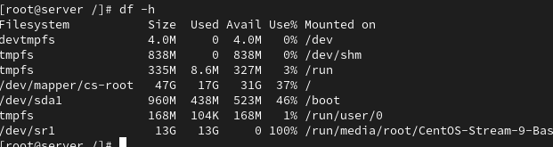
- what is the command get disk details?

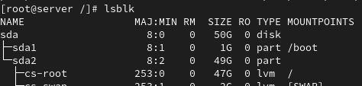
- How to see the detailed volume group, physical and logical volume information?

Physical Volume:
pvdisplay
Volume Group:
vgdisplay
Logical Volume:
lvdisplay

- Attach LUN/disk 4GB, create lvm based filesystem(xfs), mountpoint should be /dev_data
fdisk /dev/sdb

pvcreate /dev/sdb1

vgcreate vgdata /dev/sdb1

lvcreate -L 4G -n lvdata vgdata

mkfs.xfs /dev/vgdata/lvdata

mkdir /dev_data

mount /dev/vgdata/lvdata /dev_data

- Extend the above /dev_data filesystem 3GB final file system size should be 7GB?
lvextend -L +3G /dev/vgdata/lvdata

xfs_growfs /dev_data

- reduce above /dev_data filesystem 2GB?

❌ Not possible with XFS
Only ext4 supports reduction.

- Attach LUN/disk 6GB, create lvm based filesystem(ext4), mountpoint should be /prod_data

fdisk /dev/sdc

pvcreate /dev/sdc1

vgcreate vgprod /dev/sdc1

lvcreate -L 6G -n lvprod vgprod

mkfs.ext4 /dev/vgprod/lvprod

mkdir /prod_data

mount /dev/vgprod/lvprod /prod_data

- reduce above lvm filesystem 2GB and final size of filesystem should be 4G?
umount /prod_data

e2fsck -f /dev/vgprod/lvprod

resize2fs /dev/vgprod/lvprod 4G

lvreduce -L 4G /dev/vgprod/lvprod

mount /prod_data
- is it possible to reduce the xfs filesystem?

❌ No
XFS only supports increase, not reduction.

- Attach disk 4GB, create partition-based filesystem, mountpoint should be /drive

fdisk /dev/sdd

mkfs.ext4 /dev/sdd1

mkdir /drive

mount /dev/sdd1 /drive

- Attach disk 6GB, create partitions 3GB & 3GB respectively and create filesystem

fdisk /dev/sde
Create:
/dev/sde1 → 3GB
/dev/sde2 → 3GB
Filesystem:
mkfs.ext4 /dev/sde1
mkfs.ext4 /dev/sde2
Mount:
mount /dev/sde1 /mnt1
mount /dev/sde2 /mnt2
- Attach disk 3GB, create raw disk-based filesystem, mount point should be /device
mkfs.ext4 /dev/sdf
mkdir /device
mount /dev/sdf /device

- What are the steps involved to create the logical volume from scratch?

- Create partition
- Create physical volume
- Create volume group
- Create logical volume
- Create filesystem
- Create mount point
- Mount filesystem

- what is swap?

Swap is virtual memory used when RAM is full.
It uses disk space as memory.

- create 3Gb swap filesystem and enable swap?

fdisk /dev/sdg
mkswap /dev/sdg1
swapon /dev/sdg1
Check:
swapon -s

- create 2GB swap file and enable swap

dd if=/dev/zero of=/swapfile bs=1M count=2048
chmod 600 /swapfile
mkswap /swapfile
swapon /swapfile
Check:
free -h

SSH
====
- what is ssh?
SSH (Secure Shell) is a secure network protocol used to remotely access and manage another Linux system over an encrypted connection.

- port number of SSH?

22

- Is it possible to change ssh port number?

/etc/ssh/sshd_config

- Write command to login remote machine in terminal?

ssh ranjith@192.168.1.20

- Write command to login local machine in terminal?

ssh localhost

- ssh configuration file location?

Server configuration file:
/etc/ssh/sshd_config
Client configuration file:
/etc/ssh/ssh_config

- configure SSH key based authentication? write path of key file location? server1-user: admin1 to server2-user: admin1

Step 1 – Generate key on Server1
ssh-keygen
Step 2 – Copy key to Server2
ssh-copy-id admin1@server2_ip
Key file location:
Private key
/.ssh/id_rsa
Public key
/.ssh/id_rsa.pub
Authorized keys on remote system:
/.ssh/authorized_keys

- what is the command to generate the ssh key?

ssh-keygen
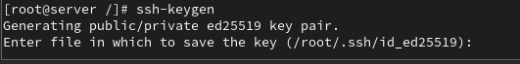

- what is the command to copy the keys to remote machine?

ssh-copy-id ranjith@192.168.1.20

- when you generate the key what are files will be create?

.ssh/
- what is the ssh daemon name?

sshd

- write ssh service-related commands which you know?

Start SSH
systemctl start sshd
Stop SSH
systemctl stop sshd
Restart SSH
systemctl restart sshd

- Disable ssh root login?

Edit file:
/etc/ssh/sshd_config
Change:
PermitRootLogin no
Restart SSH:
systemctl restart sshd

Cron
=======
- what is cronjob?

A cron job is a Linux scheduler used to run commands or scripts automatically at a specified time and date.
It runs using the cron daemon.

- what are the fields in cronjob?

* * * * * command
Field | Meaning
 | Minute (0–59)
 | Hour (0–23)
 | Day of month (1–31)
 | Month (1–12)
 | Day of week (0–7)

- how to edit cronjob?

crontab -e

- How to list cronjob?

crontab -l

- how to remove cronjob?

crontab -r

- how to edit, list, remove other users cronjob?

Edit:
crontab -u username -e
List:
crontab -u username -l
Remove:
crontab -u username -r

- what is the cron log file?

/var/log/cron
View log:
tail -f /var/log/cron

- schedule cronjob at yearly once?

0 0 1 1 * /script.sh

- schedule cronjob at monthly once?

@monthly /script.sh

- schedule cronjob at daily once?

0 0 * * * /script.sh

- schedule cronjob at hourly once?

@hourly /script.sh
or
0 * * * * /script.sh

- schedule the cronjob at machine reboot?

@reboot /script.sh
- schedule task every weekday (Monday to Friday) at 10pm.

0 22 * * 1-5 /script.sh

- Perform a backup at midnight every Tuesday.

0 0 * * 2 /backup.sh

- Perform monitoring every minute during January, February, and May.\

* * * 1,2,5 * /monitor.sh

- Clear the cache every 10 minutes at 5am, starting from 5:10am.

10-59/10 5 * * * /clear_cache.sh

- Make the task run quarterly on the first day of the month at 8am.

0 8 1 1,4,7,10 * /task.sh

- Create a backup every hour.

0 * * * * /backup.sh

- Include multiple tasks on a single cron job. Useful for scheduling multiple tasks to run at the same time.

0 2 * * * /script1.sh; /script2.sh; /script3.sh

- Clear cache every time you turn on the system.
@reboot /clear_cache.sh
Network
========
- Add additional ethernet card and assign static ip

Check interface name:

ip a

Edit network configuration file:

vi /etc/sysconfig/network-scripts/ifcfg-eth1

Example configuration:
DEVICE=eth1
BOOTPROTO=none
ONBOOT=yes
IPADDR=192.168.1.100
PREFIX=24
GATEWAY=192.168.1.1
DNS1=8.8.8.8
Restart network:
systemctl restart NetworkManager

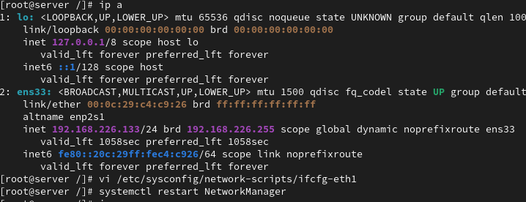

- Add additional ethernet card and assign dynamic ip

Edit interface file:
vi /etc/sysconfig/network-scripts/ifcfg-eth1
Configuration:
DEVICE=eth1
BOOTPROTO=dhcp
ONBOOT=yes
Restart network:
systemctl restart NetworkManager

- how to check the server IP also show the current IP details?

Ifconfig or ip a

- how to check the server routes also show current route details?

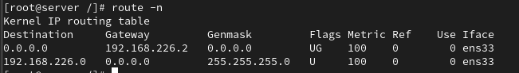

- add two ethernet card ans assignee one ip?

Example interfaces:
- eth1
- eth2
Assign IP to only one interface.
Example:
ip addr add 192.168.1.20/24 dev eth1
Bring interfaces up:
ip link set eth1 up
ip link set eth2 up

- assign two ip address for one Ethernet card?

Example:
ip addr add 192.168.1.10/24 dev eth0
ip addr add 192.168.1.20/24 dev eth0
Permanent configuration:
vi /etc/sysconfig/network-scripts/ifcfg-eth0:0
Example:
DEVICE=eth0:0
IPADDR=192.168.1.20
PREFIX=24
ONBOOT=yes

- how to check the server hostname

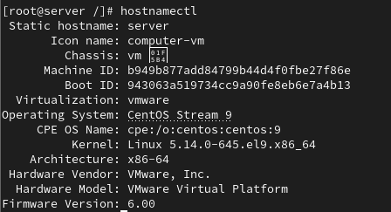

- change server hostname as server.glotechcorp.com permanently

hostnamectl set-hostname Ranjith
reboot

Find
====
- How would you use the `find` command to search for all files with the `.txt` extension in the `/home` directory?

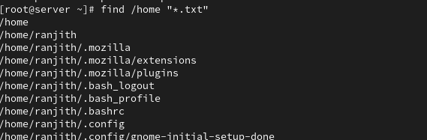

- Write a command using `find` to search for files larger than 100MB in the `/var` directory.

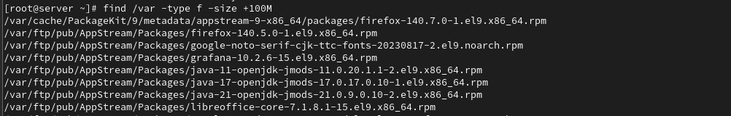

- Use `find` to locate all files in the `/etc` directory that were modified within the last 7 days.

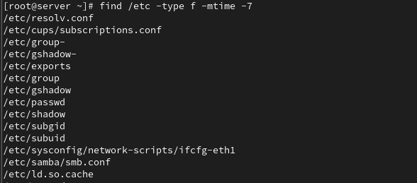

- How can you use `find` to search for files owned by a specific user, for example, `user1`, in the `/home` directory?

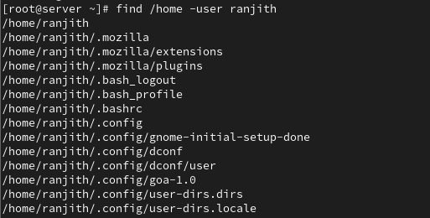

- Find all symbolic links within the `/usr` directory using the `find` command.

find /usr -type l

- Write a `find` command to delete all `.log` files in the `/tmp` directory.

find /tmp -type f -name "*.log" -delete

- How would you use the `find` command to locate files with the permissions `644` within `/etc`?

find /etc -type f -perm 644

- Use the `find` command to locate all files named `index.html` starting from the root directory (`/`).

find / -type f -name "index.html"

- Write a command using `find` to search for directories (not files) named `backup` within the `/var` directory.
find /var -type d -name "backup"

- How would you find all empty files within the `/home/user/Documents` directory using `find`?

find /home/user/Documents -type f -empty

Locate
======
1. How would you use the `locate` command to find all files containing the name `bashrc`?

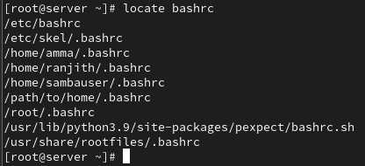

2. Write a `locate` command to search for files with the `.conf` extension on your system.

3. How can you use `locate` to find all occurrences of a file named `hosts` in the filesystem?

locate hosts

4. Use the `locate` command to find directories containing the name `bin` in their path.

locate bin | grep "/bin"

5. Write a `locate` command to find files related to the program `ssh`.

locate ssh

6. How would you use `locate` to search for files that were updated in the last 24 hours?

First update database:
updatedb
Then use:
locate -c
Note: locate normally cannot filter by time directly, because it searches a database. Use find for accurate time-based search.

7. Use the `locate` command to find all files and directories containing the word `apache`.

locate apache

8. Write a `locate` command to search for all files in the `/usr` directory that contain the string `lib`.

locate /usr | grep lib

9. How can you update the `locate` database manually before performing a search?

updatedb

10. Write a `locate` command to find all files with the `.jpg` extension.

updatedb

